**Part 1: SDG Selection and Problem Definition**

**My SDG: SDG 4: Quality Education**

Quality education is a fundamental human right and is essential for the development of societies. However, disparities exist in access to quality education between urban and rural areas, particularly in developing countries. By focusing on this SDG, the goal is to identify and address the issues contributing to these disparities.

#### **Problem Definition**

**Specific Problem**: Unequal access to quality education in rural versus urban areas in a developing country.

**Part 2: Database Design**

**My Entities and their Relationships:**

1. **Regions**: Contains information about different regions (urban and rural).
   * Fields: RegionID, RegionName, Population, AverageIncome
2. **Schools**: Contains information about schools in each region.
   * Fields: SchoolID, SchoolName, RegionID, InfrastructureQuality, NumberOfStudents
3. **Teachers**: Contains information about teachers in each school.
   * Fields: TeacherID, TeacherName, SchoolID, Qualification, ExperienceYears
4. **Students**: Contains information about students in each school.
   * Fields: StudentID, StudentName, SchoolID, PerformanceScore
5. **Courses**: Contains information about courses offered in schools.
   * Fields: CourseID, CourseName, SchoolID, TeacherID, CourseDuration

**Relationships**:

* **Regions** have many **Schools**.
* **Schools** have many **Students**.
* **Schools** have many **Teachers**.
* **Schools** offer many **Courses**.
* **Courses** are taught by one **Teacher**.

**MY ERD (Entity-Relationship Diagram)**

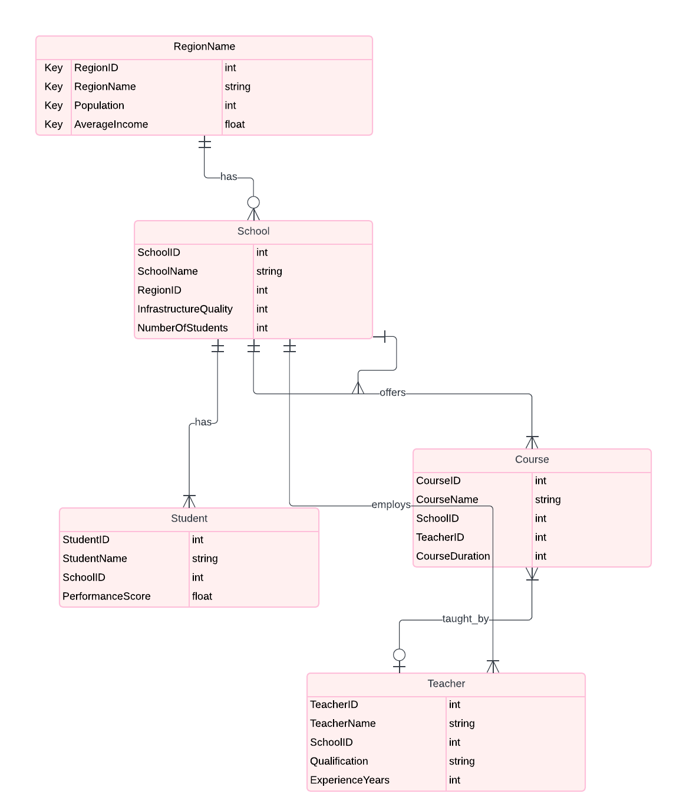

**Schema**

**SQL Statements:**

CREATE TABLE Regions (

RegionID INT PRIMARY KEY,

RegionName VARCHAR(255),

Population INT,

AverageIncome DECIMAL(10,2)

);

CREATE TABLE Schools (

SchoolID INT PRIMARY KEY,

SchoolName VARCHAR(255),

RegionID INT,

InfrastructureQuality VARCHAR(255),

NumberOfStudents INT,

FOREIGN KEY (RegionID) REFERENCES Regions(RegionID)

);

CREATE TABLE Teachers (

TeacherID INT PRIMARY KEY,

TeacherName VARCHAR(255),

SchoolID INT,

Qualification VARCHAR(255),

ExperienceYears INT,

FOREIGN KEY (SchoolID) REFERENCES Schools(SchoolID)

);

CREATE TABLE Students (

StudentID INT PRIMARY KEY,

StudentName VARCHAR(255),

SchoolID INT,

PerformanceScore DECIMAL(5,2),

FOREIGN KEY (SchoolID) REFERENCES Schools(SchoolID)

);

CREATE TABLE Courses (

CourseID INT PRIMARY KEY,

CourseName VARCHAR(255),

SchoolID INT,

TeacherID INT,

CourseDuration INT,

FOREIGN KEY (SchoolID) REFERENCES Schools(SchoolID),

FOREIGN KEY (TeacherID) REFERENCES Teachers(TeacherID)

);

Sample Data

**Example SQL for Populating Tables:**

INSERT INTO Regions (RegionID, RegionName, Population, AverageIncome) VALUES

(1, 'Urban', 500000, 15000.00),

(2, 'Rural', 200000, 8000.00);

INSERT INTO Schools (SchoolID, SchoolName, RegionID, InfrastructureQuality, NumberOfStudents) VALUES

(1, 'Urban High School', 1, 'High', 1000),

(2, 'Rural Primary School', 2, 'Low', 300);

INSERT INTO Teachers (TeacherID, TeacherName, SchoolID, Qualification, ExperienceYears) VALUES

(1, 'John Doe', 1, 'Masters', 10),

(2, 'Jane Smith', 2, 'Bachelors', 5);

INSERT INTO Students (StudentID, StudentName, SchoolID, PerformanceScore) VALUES

(1, 'Alice', 1, 85.5),

(2, 'Bob', 2, 60.0);

INSERT INTO Courses (CourseID, CourseName, SchoolID, TeacherID, CourseDuration) VALUES

(1, 'Math', 1, 1, 180),

(2, 'Science', 2, 2, 180);

**Part 3: SQL Programming**

**Data Retrieval**

Example SQL Queries:

**1: Retrieve all schools in rural areas:**

SELECT SchoolName, InfrastructureQuality, NumberOfStudents

FROM Schools

INNER JOIN Regions ON Schools.RegionID = Regions.RegionID

WHERE RegionName = 'Rural';

**2: Get the teacher-student ratio in each region:**

SELECT RegionName, COUNT(Teachers.TeacherID) AS NumberOfTeachers, SUM(NumberOfStudents) AS TotalStudents,

SUM(NumberOfStudents) / COUNT(Teachers.TeacherID) AS TeacherStudentRatio

FROM Schools

INNER JOIN Regions ON Schools.RegionID = Regions.RegionID

INNER JOIN Teachers ON Schools.SchoolID = Teachers.SchoolID

GROUP BY RegionName;

**3: Compare student performance between urban and rural areas:**

SELECT RegionName, AVG(PerformanceScore) AS AveragePerformance

FROM Students

INNER JOIN Schools ON Students.SchoolID = Schools.SchoolID

INNER JOIN Regions ON Schools.RegionID = Regions.RegionID

GROUP BY RegionName;

#### **Data Analysis**

**Insights**:

**1: Infrastructure Quality**: Comparing the infrastructure quality of schools in urban and rural areas.

* + Finding: Urban schools have significantly better infrastructure, which correlates with better student performance.

**2: Teacher-Student Ratio**: Analyzing the teacher-student ratio across regions.

* + Finding: Rural areas have a higher teacher-student ratio, leading to overworked teachers and less effective teaching.

**3: Student Performance**: Examining average student performance in different regions.

* + Finding: Urban students consistently outperform rural students, indicating a gap in educational outcomes.